**SRI MUTHUKUMARAN ARTS AND SCIENCE COLLEGE**

**(Affiliated to university of Madras)**

**CHIKKARAYAPURAM, CHENNAI - 600 069.**

**DEPARTMENT OF PHYSICS**

**Under scheme of**

**NAANMUDHALVAN**

**Project Title: Unearthing the Environmental Impact of Human Activity:**

**A Global CO2 Emission Analysis**

**Submitted By**

**SUBAASHAN D**

[**bose11103@gmail.com**](mailto:bose11103@gmail.com)

**EZHILARASI R S**

[**ezhilarasirs2002@gmail.com**](mailto:ezhilarasirs2002@gmail.com)

**RAHAMAD BEHAM U**

[**krishnangym060@gmail.com**](mailto:krishnangym060@gmail.com)

**NANDHINI R**

[**nandhiniraman20tcp@gmail.com**](mailto:nandhiniraman20tcp@gmail.com)

**Team Id: NM2023TMID24173**

**Under the mentor of**

**Dr.A.Manikandan**

[**maniphy0507@gmail.com**](mailto:Balanpoo36@gmail.com)

**Department of Physics**

**1. INTRODUCTION**

**1.1 Overview**

Carbon dioxide emissions are the primary driver of global climate change. It’s widely recognised that to avoid the worst impacts of climate change, the world needs to urgently reduce emissions. But, how this responsibility is shared between regions, countries, and individuals has been an endless point of contention in international discussions.

* 1. **Purpose**

**Global energy-related CO2 emissions grew by 0.9% or 321 Mt in 2022, reaching a new high of over 36.8 Gt.** Following two years of exceptional oscillations in energy use and emissions, caused in part by the Covid-19 pandemic, last year’s growth was much slower than 2021’s rebound of more than 6%. Emissions from energy combustion increased by 423 Mt, while emissions from industrial processes decreased by 102 Mt.

**2. PROBLEM DEFINITION AND DESIGN THINKING**

**2.1 Empathy Map**

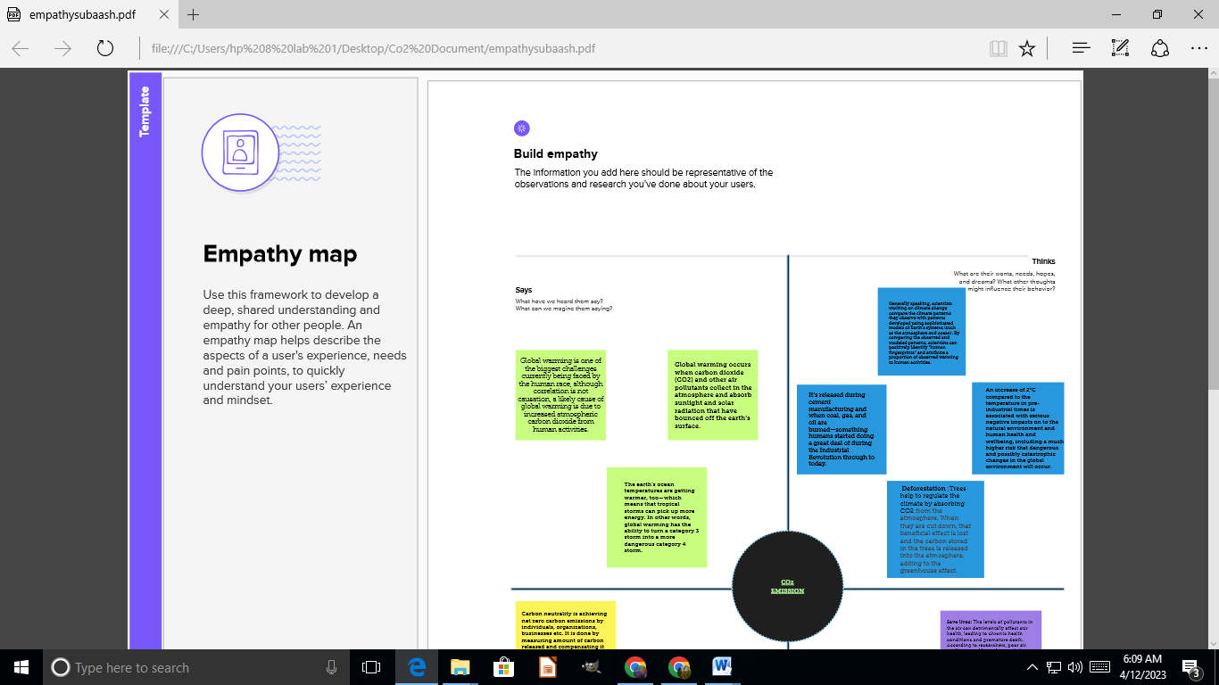

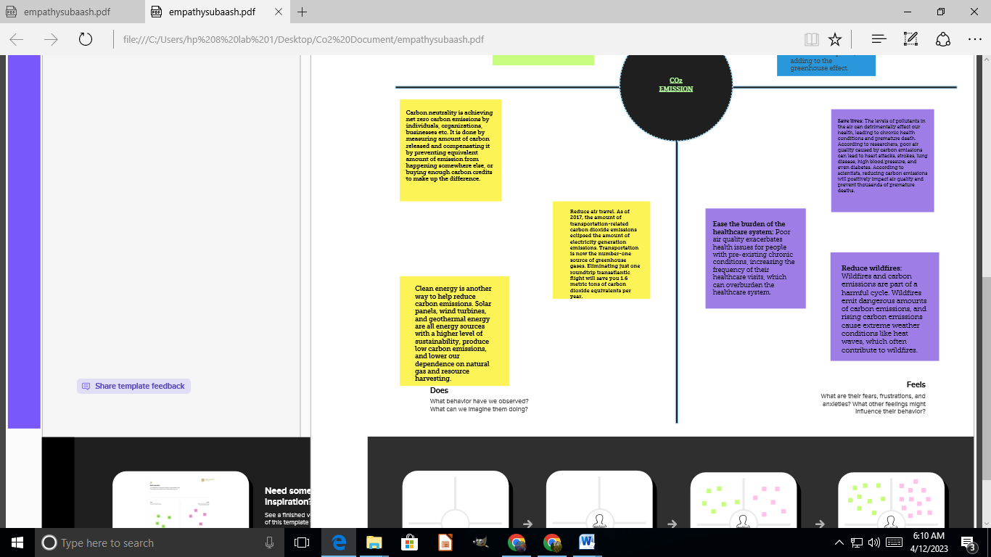

**Full Page screenshot**

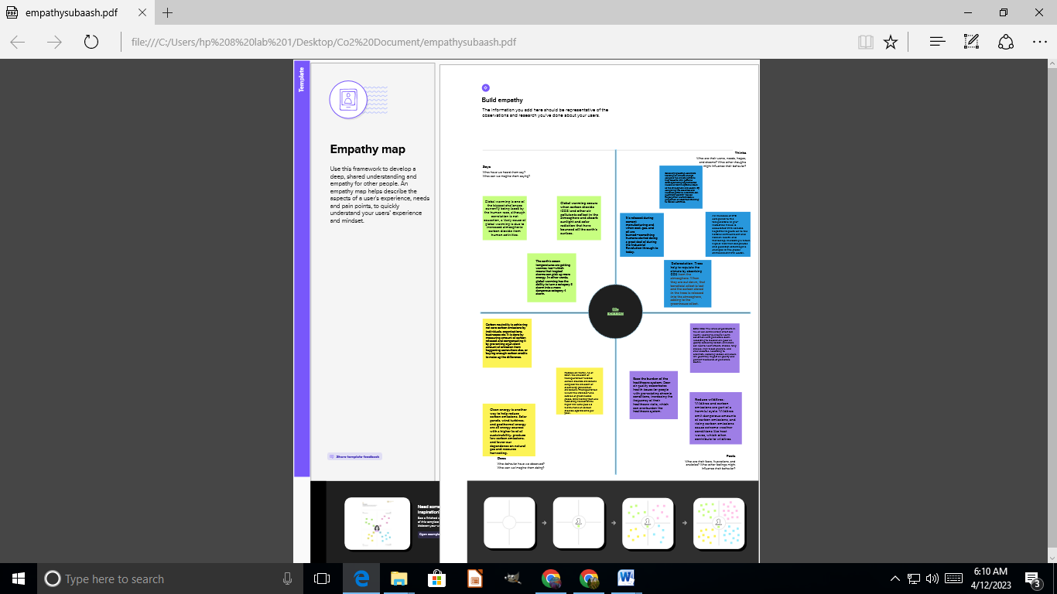

**2.2 Ideation and Brainstorming map screenshots**

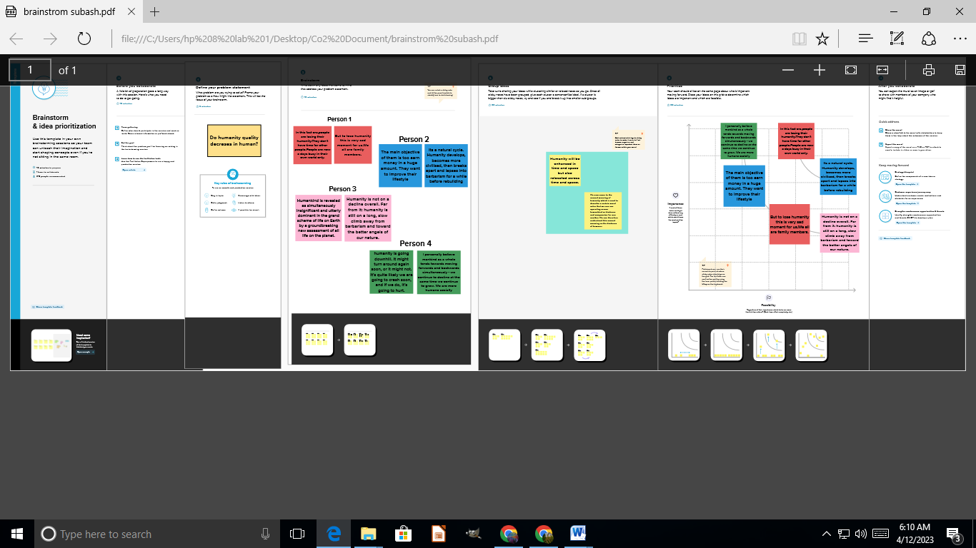

**3. Result**

**Dashboard. 1**

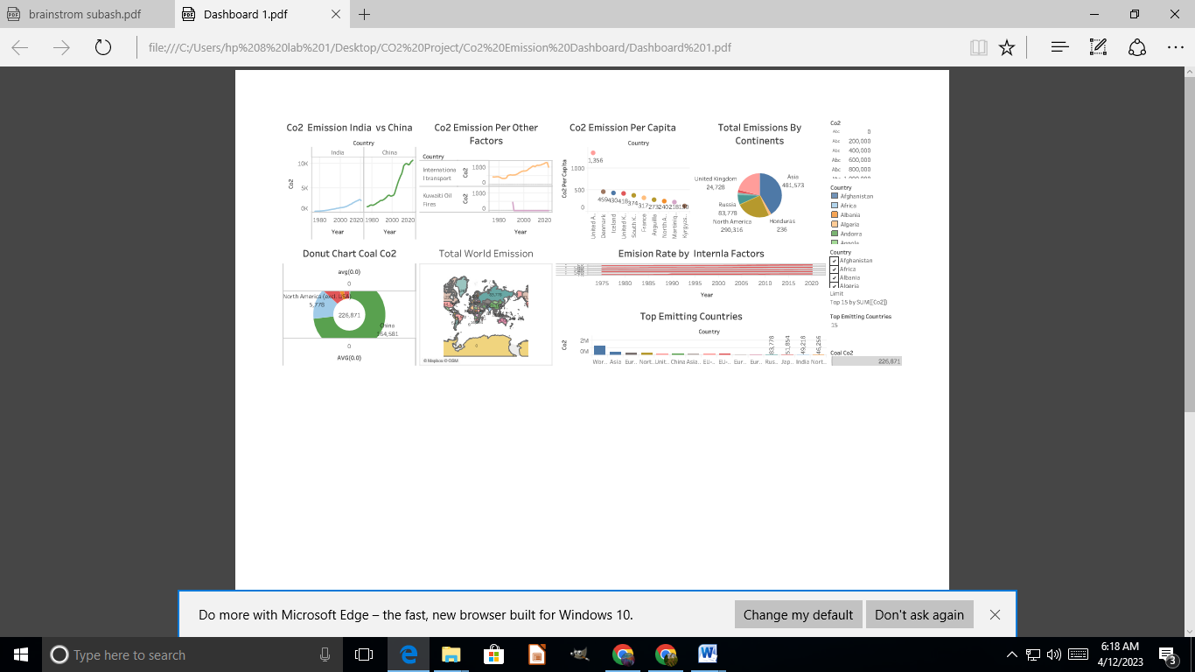

**Dashboard. 2**

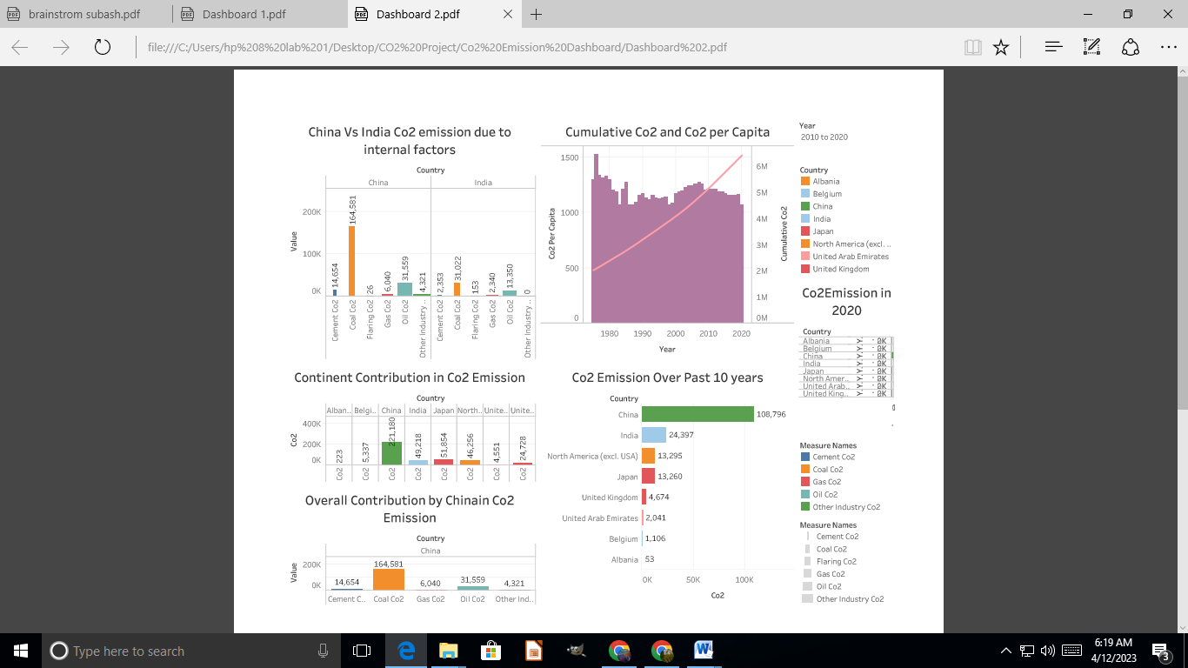

**Story Board 1**

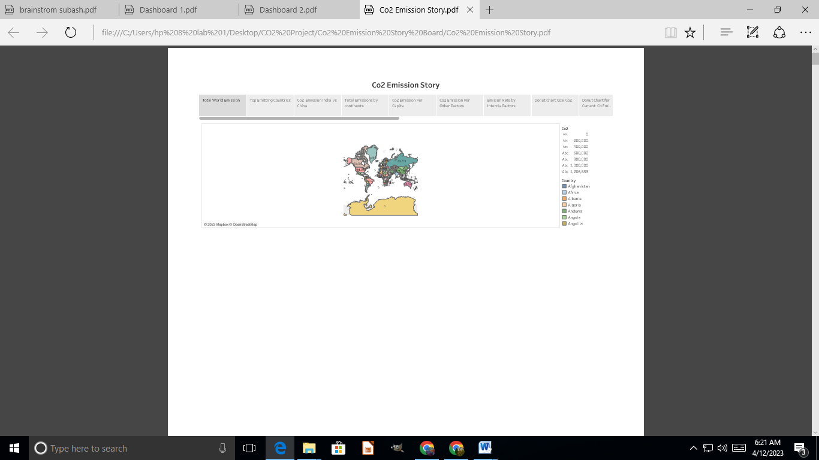

**Story Board 2**

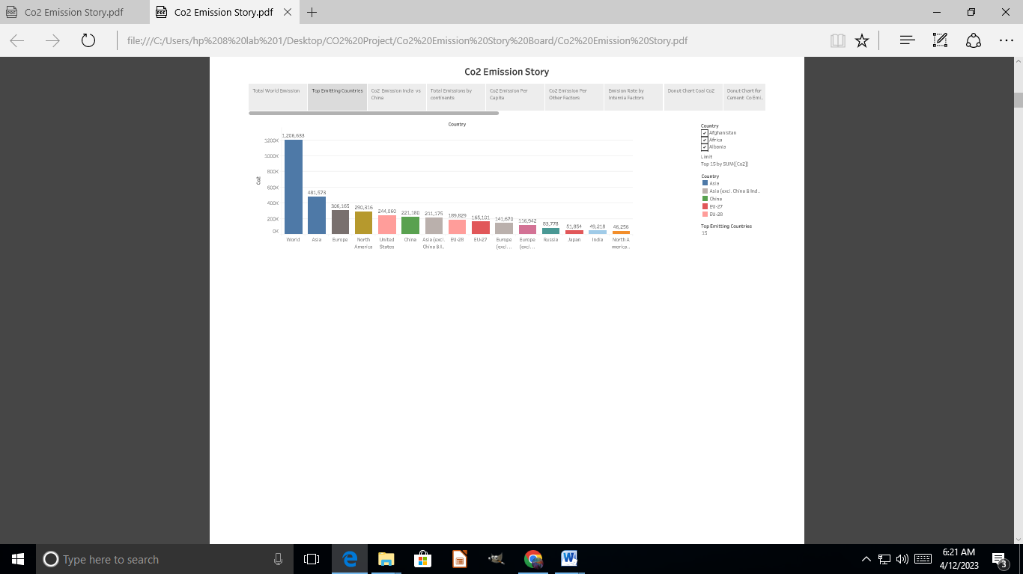

**Story Board 3**

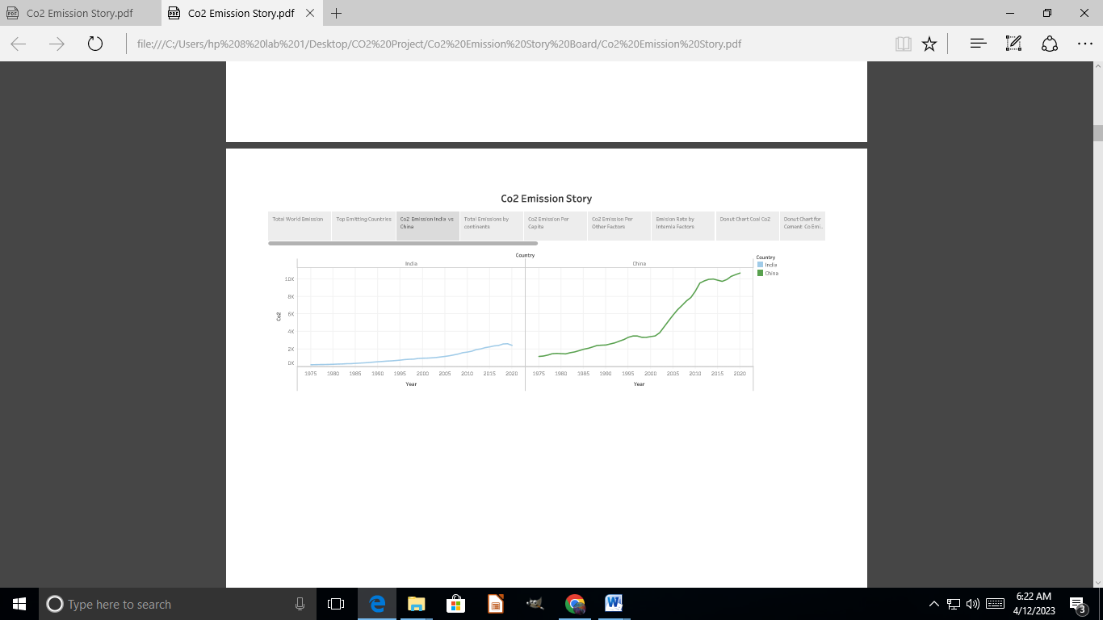

**Story Board 4**

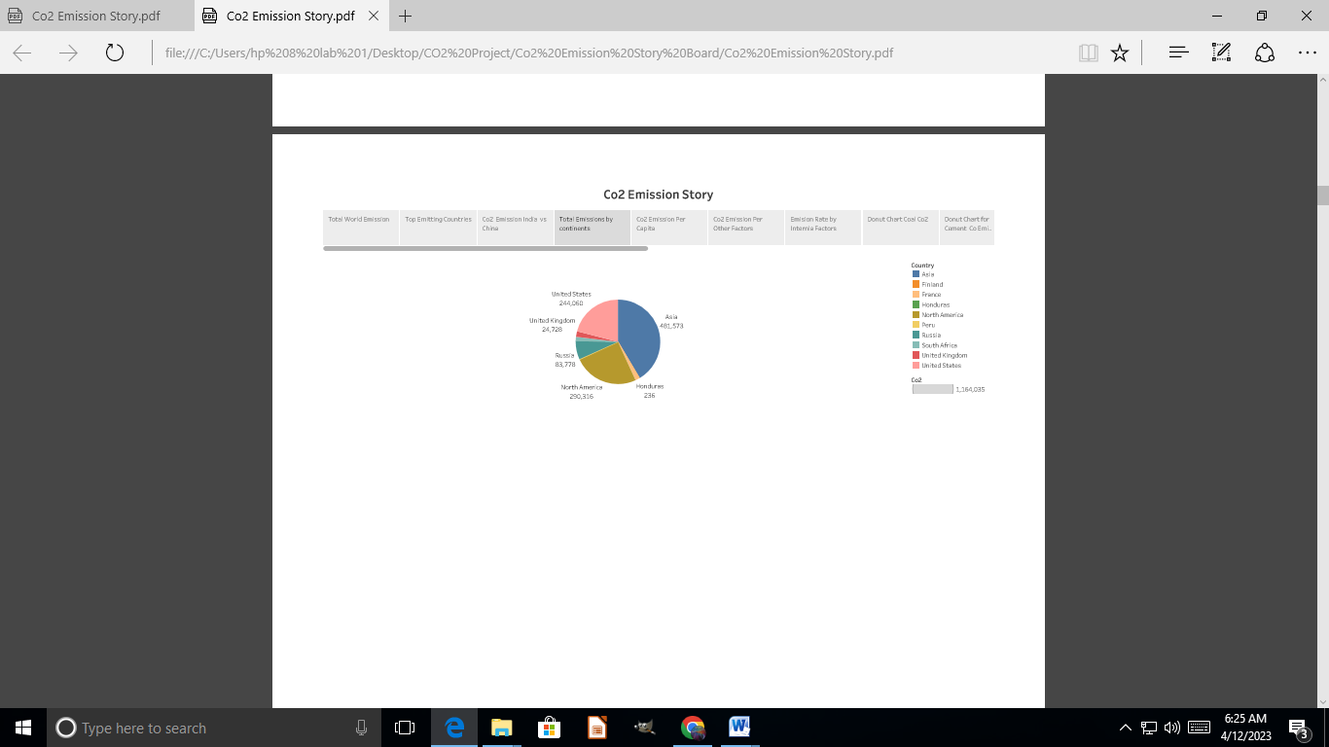

**Story Board 5**

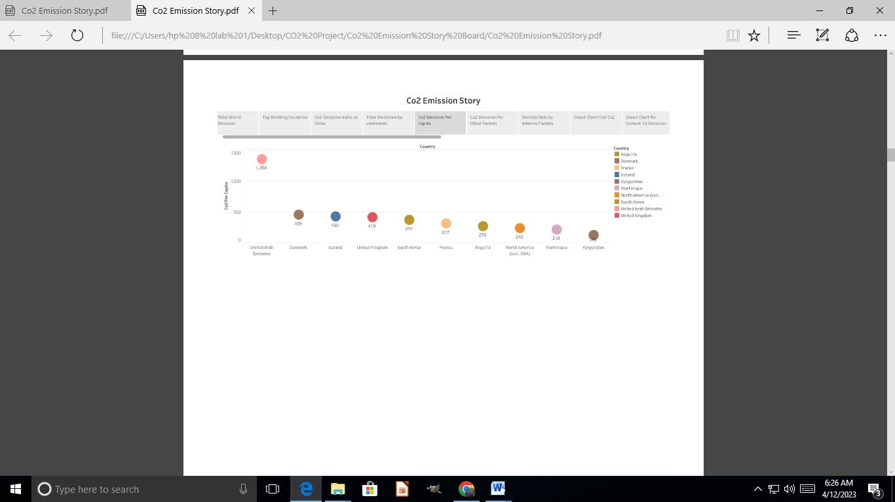

**Story Board 6**

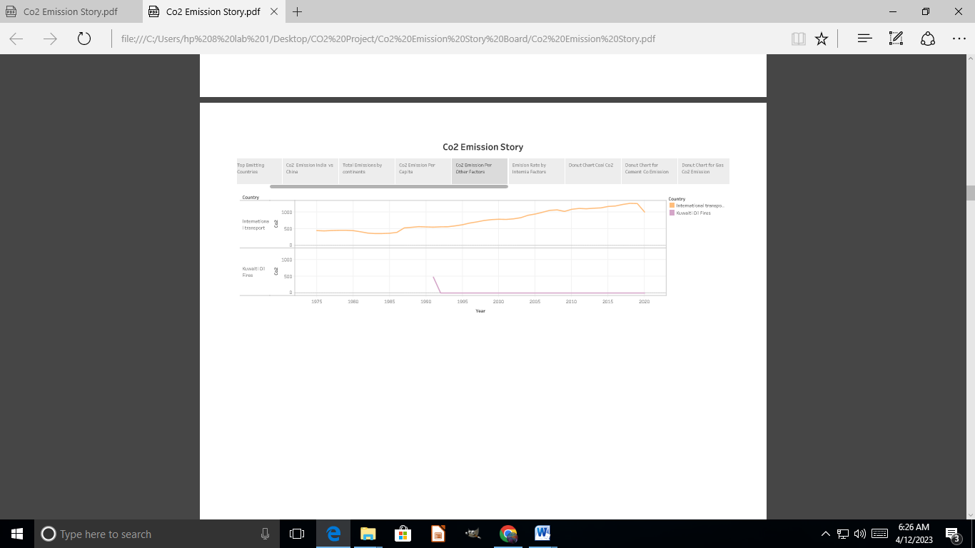

**Story Board 7**

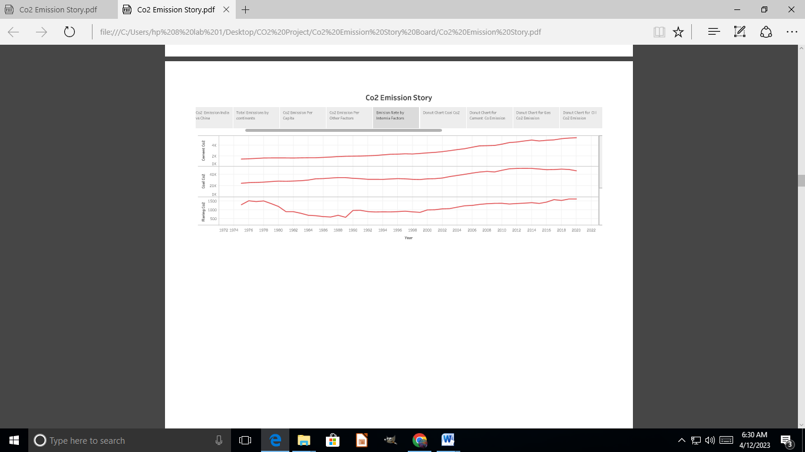

**Story Board 8**

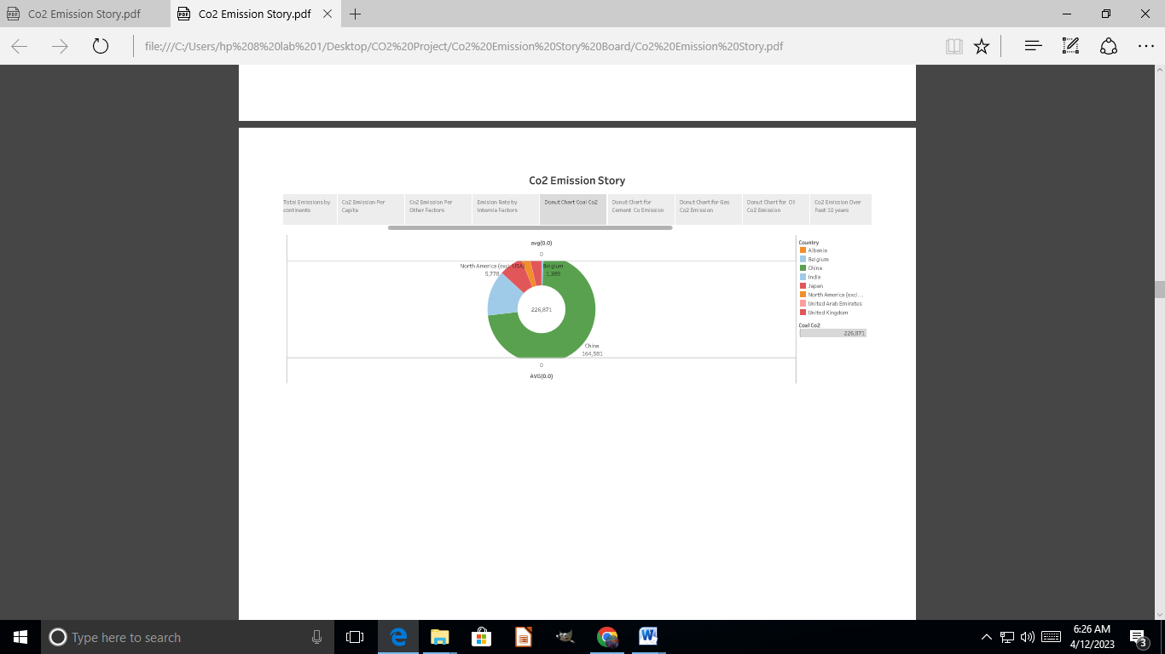

**Story Board 9**

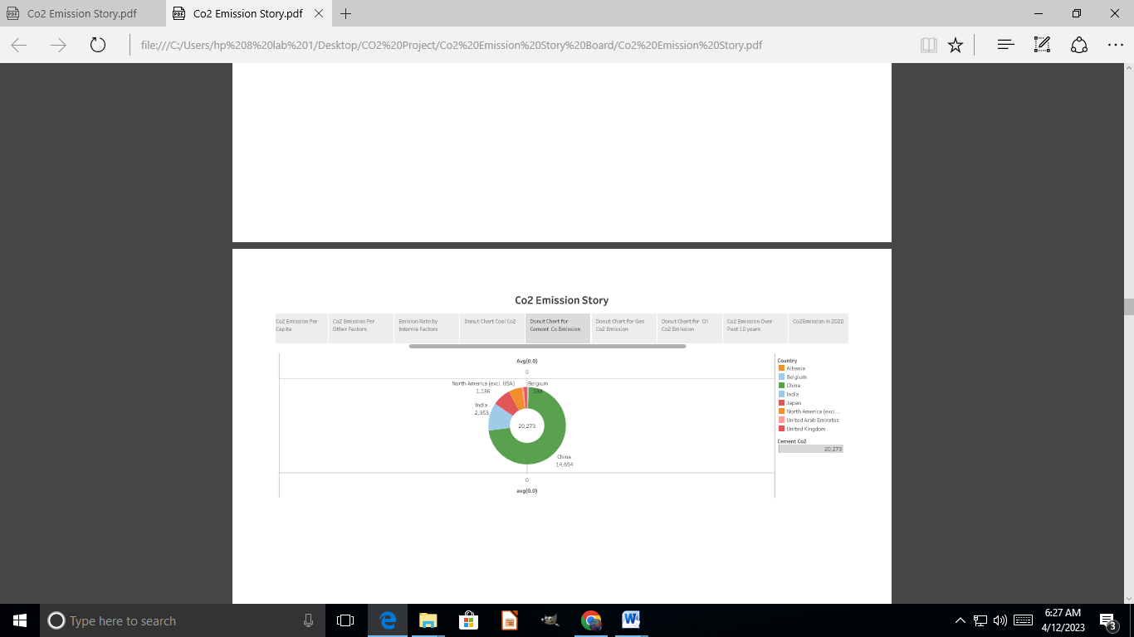

**Story Board 10**

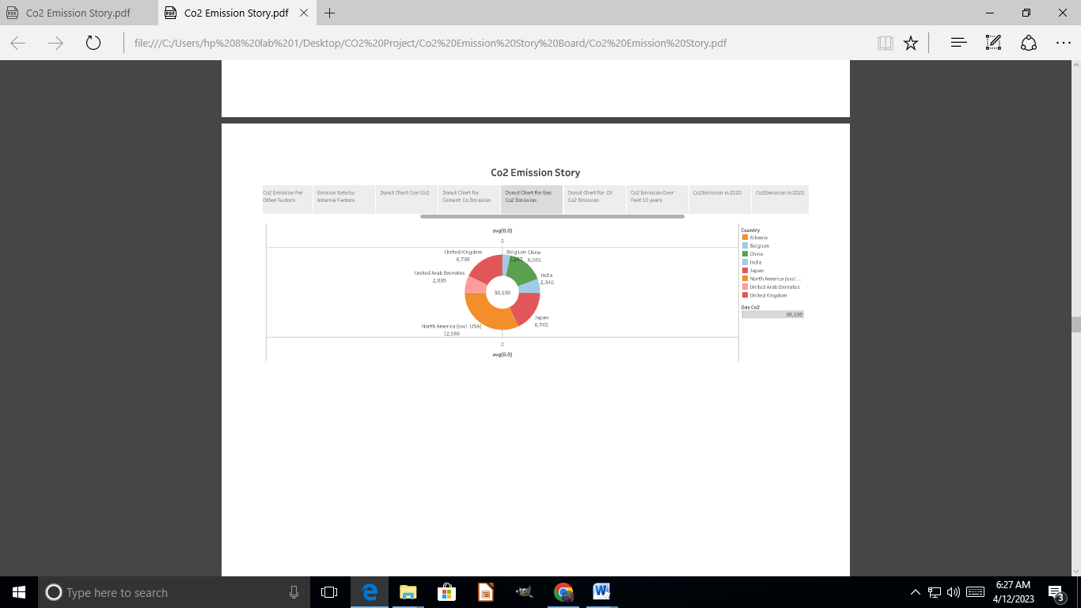

**Story Board 11**

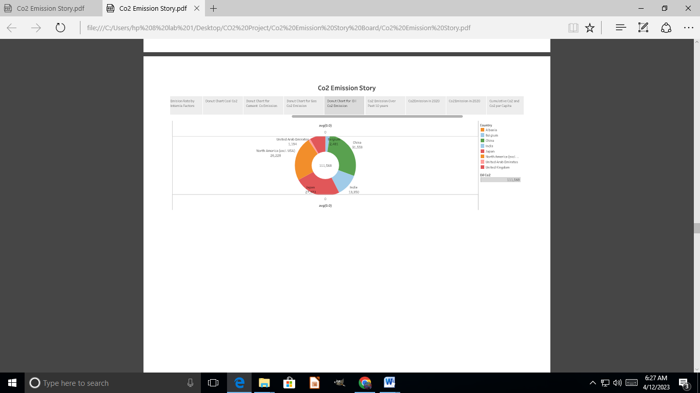

**Story Board 12**

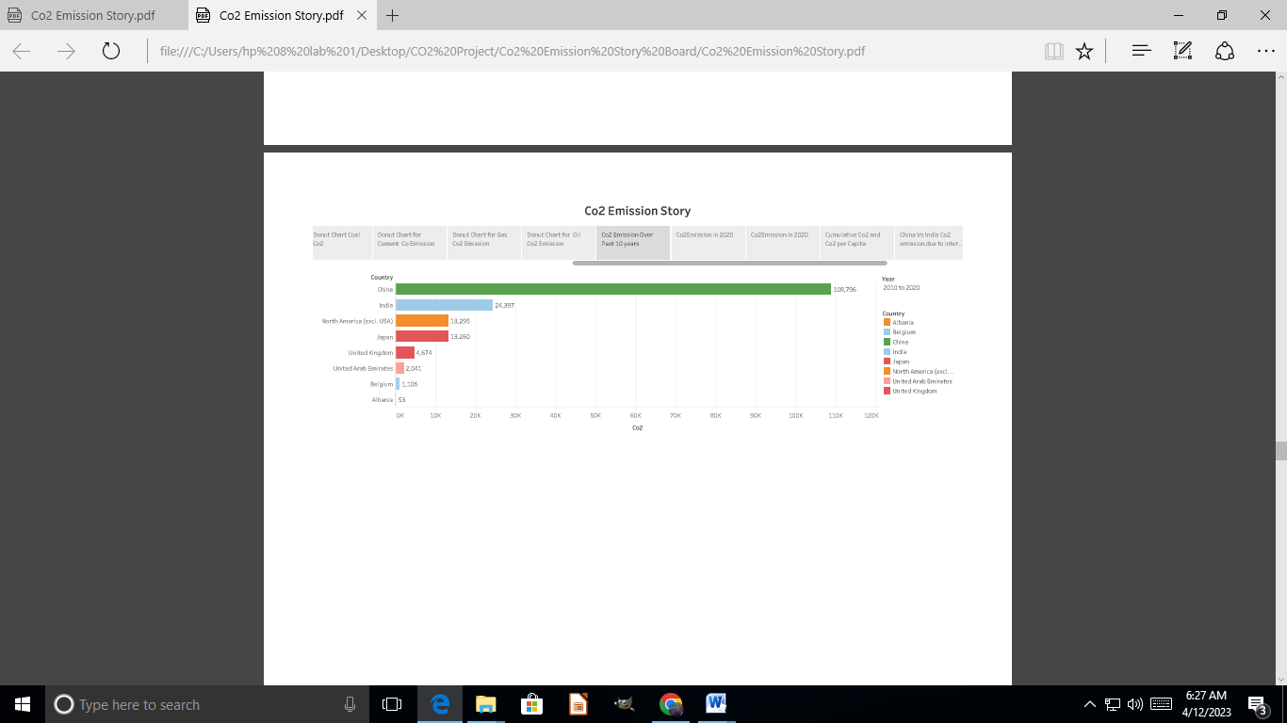

**Story Board 13**

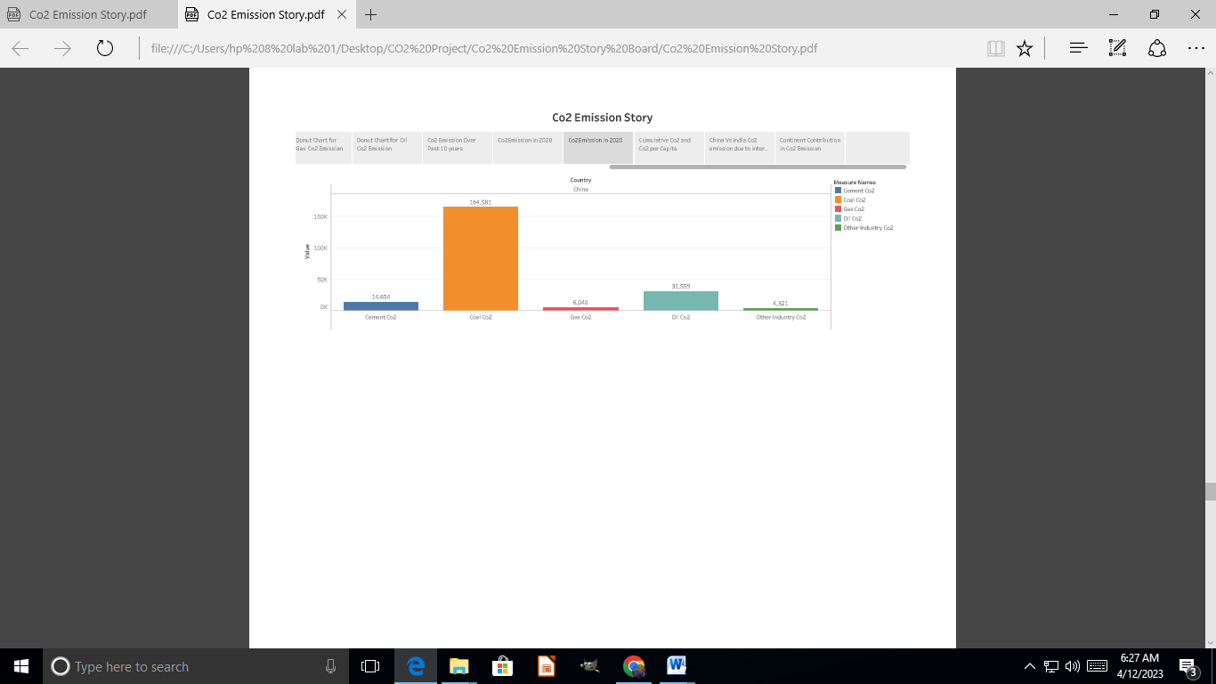

**Story Board 14**

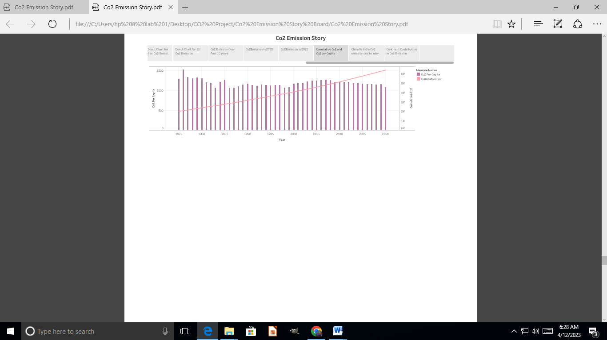

**Story Board 15**

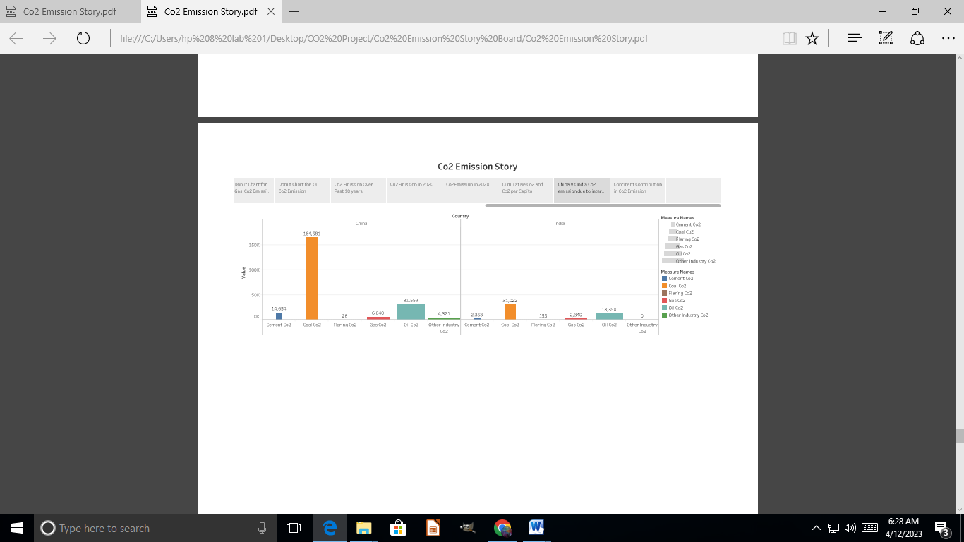

**Story Board 16**

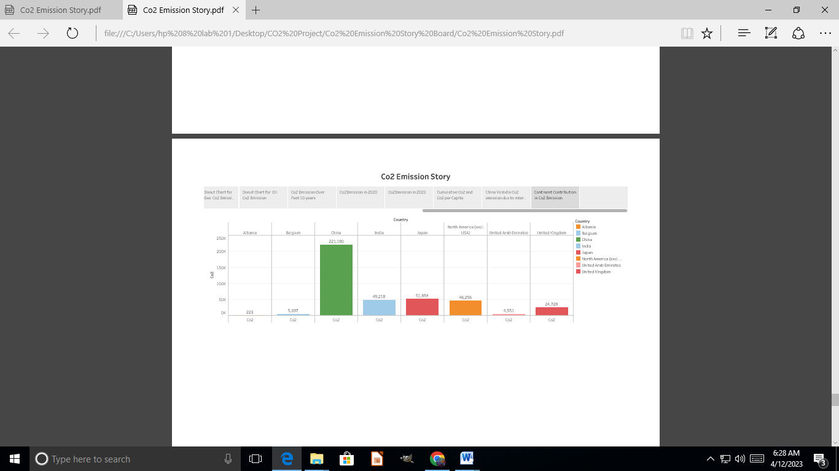

**4. Advantages and Disadvantages**

The earth's atmosphere is approximately 0.039% carbon dioxide. This might not sound like an awful lot, but the finely-tuned balance of gases in our planet's atmosphere is what keeps the earth full of life (unlike all the other planets in our solar system). Plants are especially reliant on CO2, as they use it to get energy. Plants perform a chemical reaction known as photosynthesis which requires carbon dioxide - so, without it, we'd have no plants and thus nothing to eat!. There are several negative aspects of carbon dioxide: For instance, did you know that if carbon dioxide levels reach higher than 5% in a room, this is usually enough to kill a human being? Another threat that CO2 poses comes in the form of global warming. Carbon emissions (partly due to the burning of fossil fuels) are causing a gap in our ozone layer. The ozone layer is a 'film' around the earth that protects our planet from harmful rays coming from the sun. When holes appear in this layer, harmful rays enter the earth's atmosphere and raise the temperature of the planet.  
 This is known as the 'greenhouse effect', because it's similar to the reason why greenhouses get so hot. The heating-up of the planet risks making it impossible to live on, and this can be seen as a threat that is directly related to CO2.

**5. Applications:**

Carbon neutrality is achieving net zero carbon emissions by individuals, organizations, businesses etc. It is done by measuring amount of carbon released and compensating it by preventing equivalent amount of emission from happening somewhere else, or buying enough carbon credits to make up the difference. For instance, a corporation may plant trees in different places to offset the electricity it consumes. Carbon neutrality aims at achieving a zero carbon footprint. All those organizations and individuals seeking carbon neutral status entails reducing and/or avoiding carbon emissions first so that only unavoidable emissions are offset.

**6. Conclusion:**

As a result end of the day people should stop addicting to luxury they should know what people does to earth by emitting carbon dioxide. Everything we do has a various reaction from the nature and people so do have concern before doing something.

**7.Future scope**:

Do have some concern before doing thing for our own purpose, Nature has given has liberty to change our lives but there is a limit.